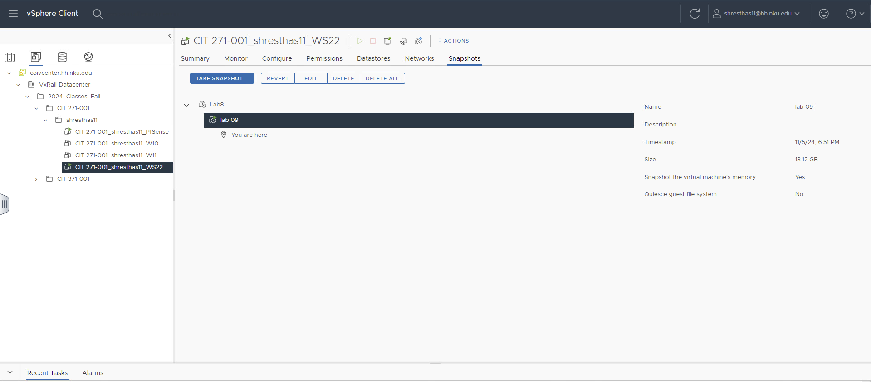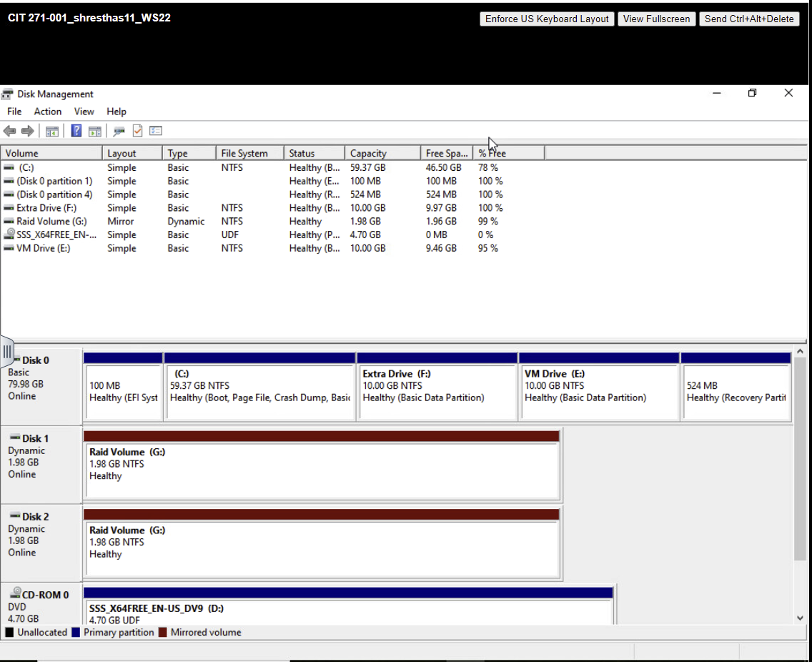

Part 2:
Get-Partition -DiskNumber 0
Resize-Partition -DiskNumber 0 -PartitionNumber 3 -Size (59.37GB)
New-Partition -DiskNumber 0 -UseMaximumSize -DriveLetter F
Format-Volume -DriveLetter F -FileSystem NTFS -NewFileSystemLabel "Extra Drive"

